PixInsight Statistics
To verify if I exposed long enough, I took some statistics in PixInsight.
The camera is a CMOS 16bit, and counts ADU thus until 65383
Preview 01 is a bit larger than the star
Preview 04 encircles the star (20pixels)
Preview 03 is the “inner core” of the star
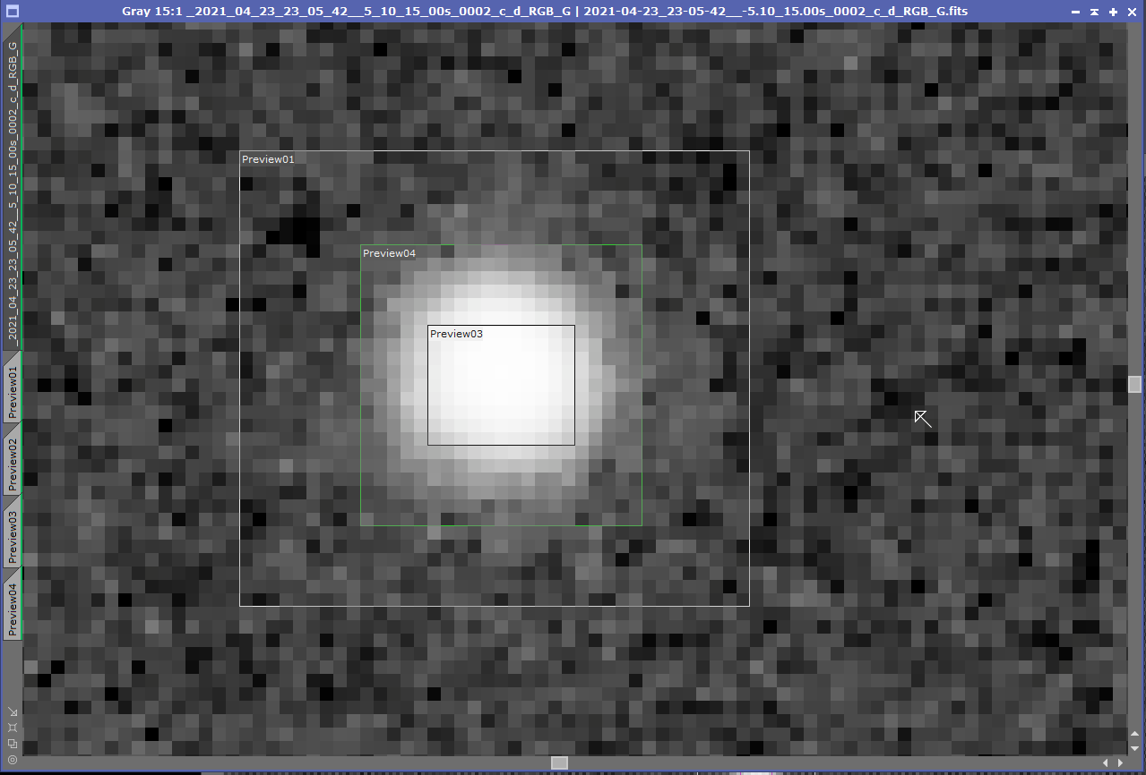
These are the stats of the three regions :
Preview 1 (large) :
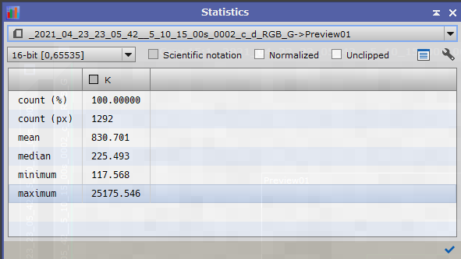
preview 4 (star) :
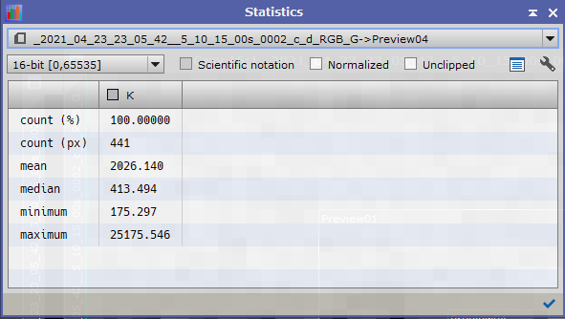
preview 3 (inner part of the star) :
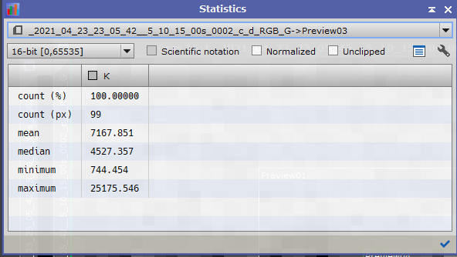

And here some stats of “pure” background :
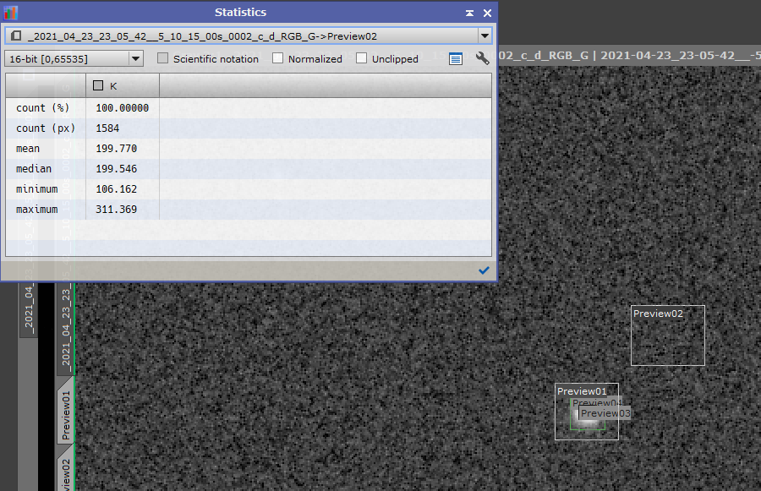

Multi Aperture Settings
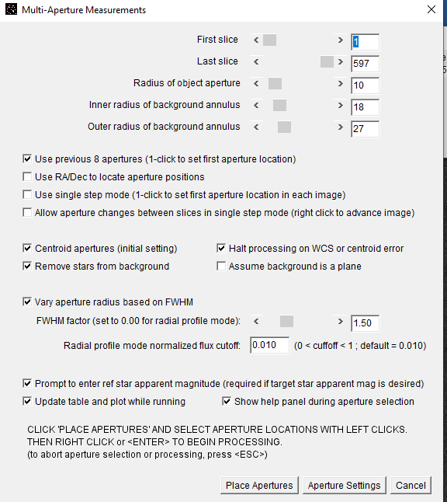

Stars (V436 UMA)
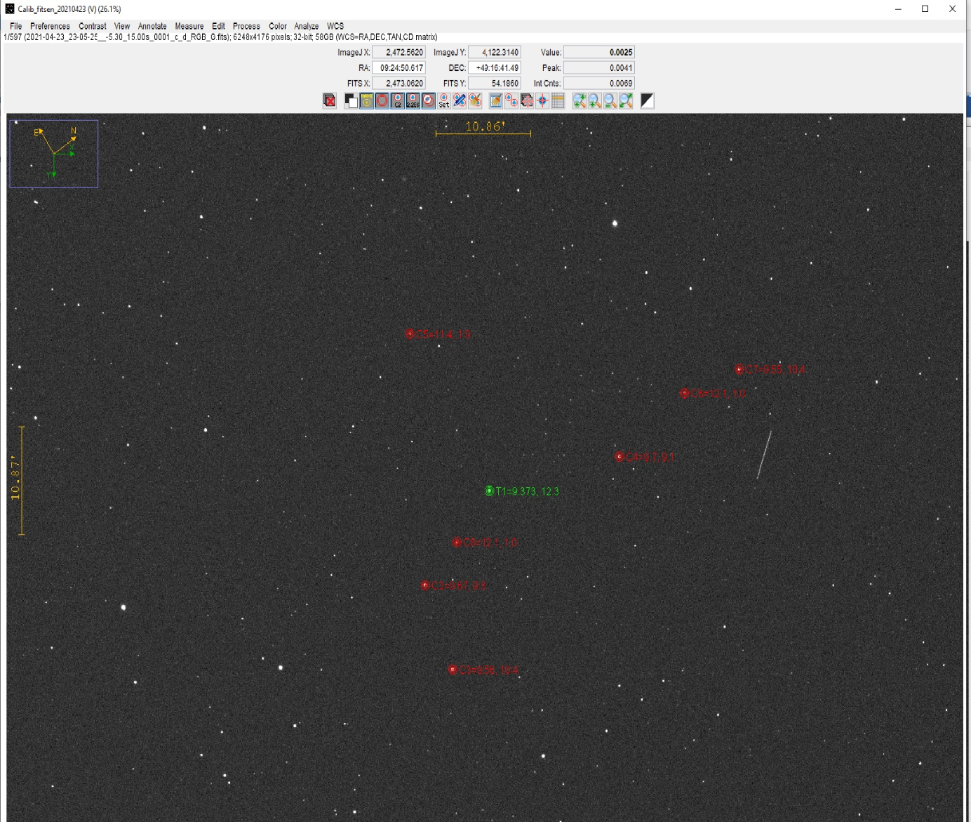
Zoomed in on the Star (V436 UMA)
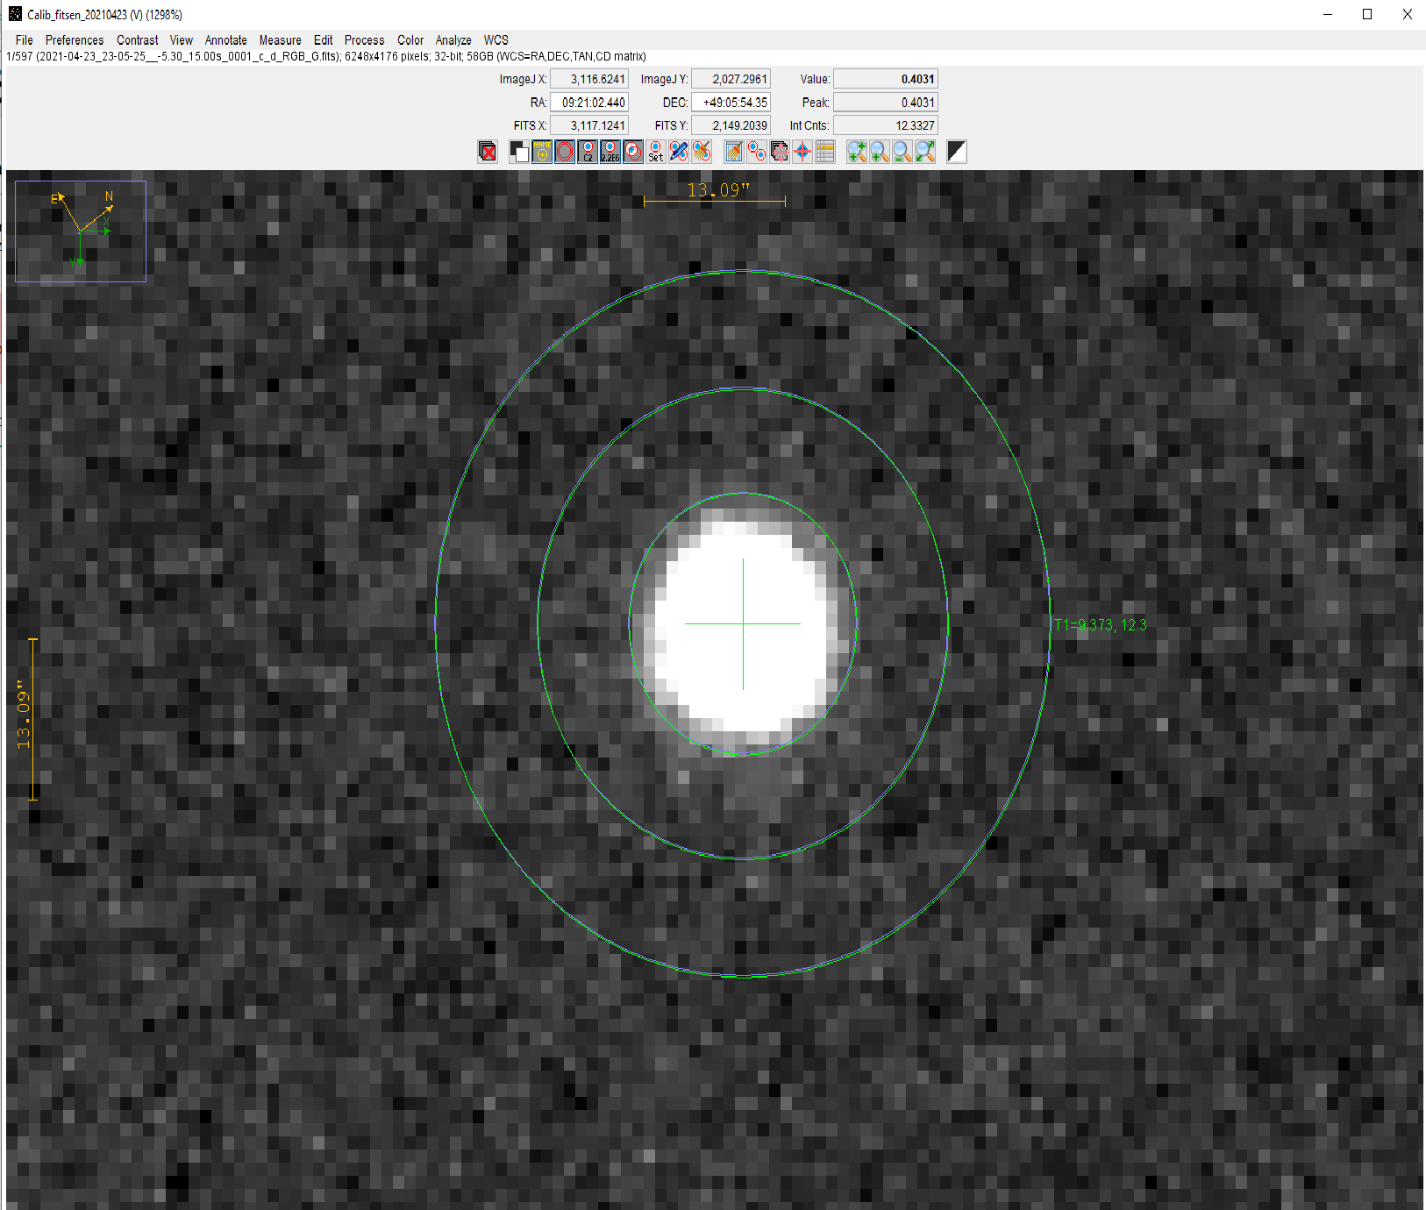

Seeing profile
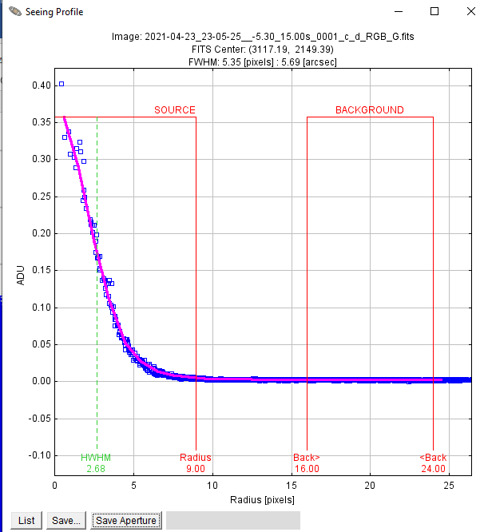

Plot Of Measures
